This source code is licensed, not sold, and is subject to a written license agreement. Among other things, no portion of this source code may be copied, transmitted, disclosed, displayed, distributed, translated, used as the basis for a derivative work, or used, in whole or in part, for any program or purpose other than its intended use in compliance with the license agreement as part of the QualNet software. This source code and certain of the algorithms contained within it are confidential trade secrets of Scalable Network Technologies, Inc. and may not be used as the basis for any other software, hardware, product or service.

SCENARIO PURPOSE: Urban Pathloss with ESRI Terrain shape files in QualNet and EXata

SCENARIO:

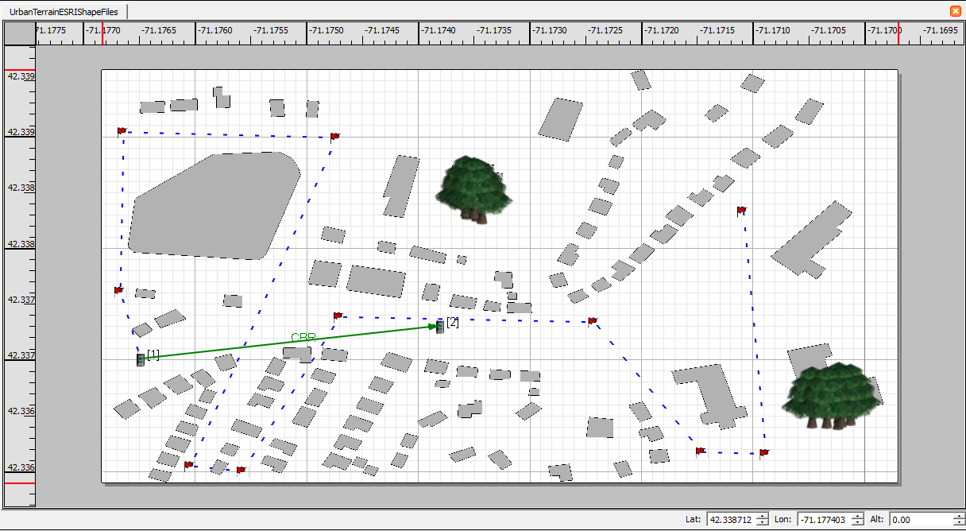

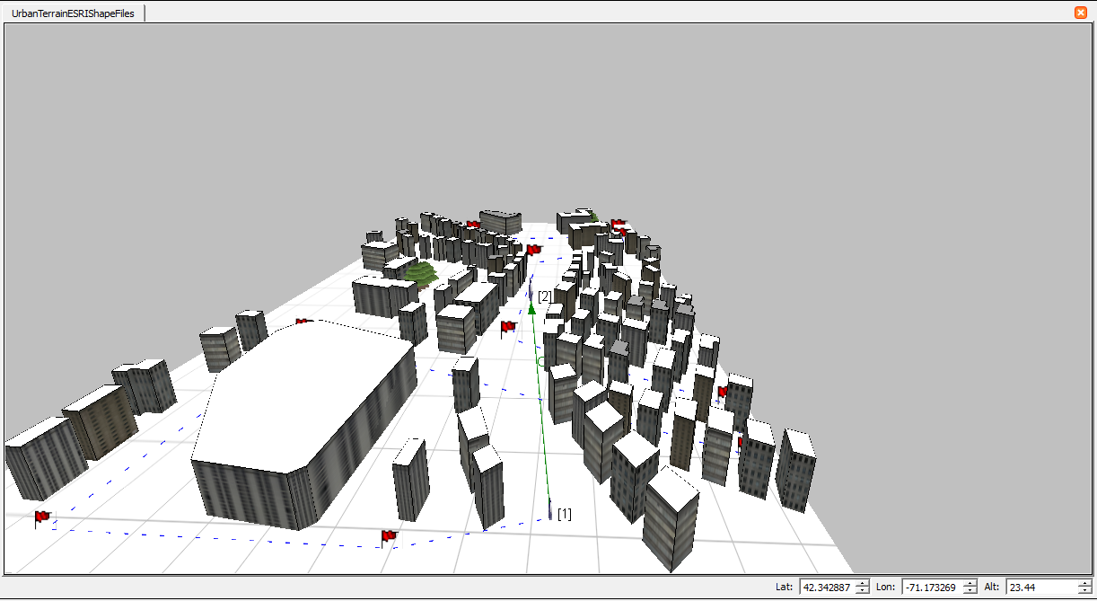

There are two nodes in the default wireless subnet. This radio is abstract, the MAC is generic and the routing protocol is AODV. The ESRI shape files are of Boston MA. CBR is the application at an interval of .01 second. Node 1 moves through the urban terrain, loosing connectivity as it moves behind/through building, pathloss is Urban Model Autoselect.

Application traffic is from the end device to an “application server”.

APPLICATIONS: CBR: Source – Node 1; Destination – Node 2

DESCRIPTION OF THE FILES:

1. UrbanTerrainESRIShapeFiles.app - QualNet configuration file for application input.
2. UrbanTerrainESRIShapeFiles.config - QualNet configuration input file.
3. UrbanTerrainESRIShapeFiles.expected.stat - QualNet statistics collection.
4. UrbanTerrainESRIShapeFiles.nodes - QualNet configuration file for node position.
5. UrbanTerrainESRIShapeFiles README.docx – This File source
6. UrbanTerrainESRIShapeFiles README.pdf – This file Distributable
7. boston_small_area_buildings.shp – ESRI spatial data format file
8. boston_small_area_buildings.shx – ESRI spatial data index file
9. boston_small_area_buildings.xml – ESRI sparial data xml definition
10. boston_small_area_trees.shp - ESRI spatial data format file
11. boston_small_area_trees.shx - ESRI spatial data index file
12. boston_small_area_trees.xml - ESRI spatial data xml definition
13. default.fading – EXata pathloss fading data file